St James and St John Church of England Primary School

School Uniform Policy 2024/25

Policy produced by School

Adopted by Governors Full Governing Body -Academic year 2024/25

Review date- Academic year 2025/26

School uniform is compulsory at our school. All children must wear the school uniform, as agreed by parents in the Home-School Agreement when their child joins our school.
Wearing our school uniform helps children to feel a sense of identity and belonging to our school community.

Cost and availability

The school meets the statutory requirements of the Education (Guidance about Costs of School Uniforms) Act 2021.

All of the uniform items listed below are required.

Most school uniform items are available to buy from Stitch Design. We have chosen Stitch Design as our school uniform provider because the items are of good quality and are reasonably priced.

Some items of school uniform may be available second hand from the school office. Please pop in to the office to ask about pre-loved uniform.

School uniform which is available to buy through the Stitch Design website:
- Maroon V-neck Sweatshirt with school logo OR Maroon Cardigan with school logo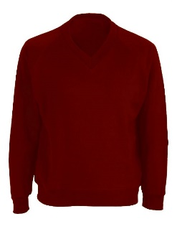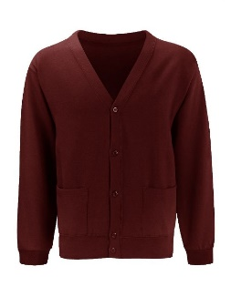
- Yellow PE T-shirt with school logo (Reception to Year Six)
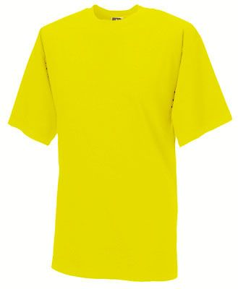
- Yellow Polo T-shirt (Nursery and Reception only)
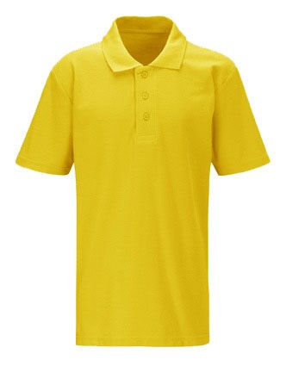
Nursery and Reception only
- Backpack with school logo

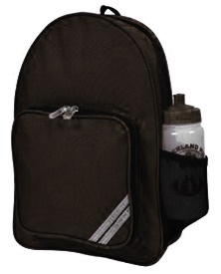

School uniform which is available from a range of High Street shops, e.g. John Lewis, Primark, Tesco, M&S etc.
- Year 1 to Year Six – White school shirt
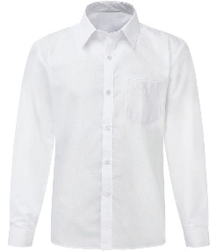

- Year 1 to Year Six – Grey school trousers / school skirt/ school pinafore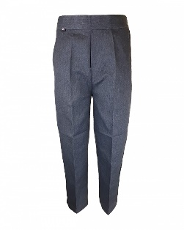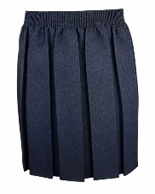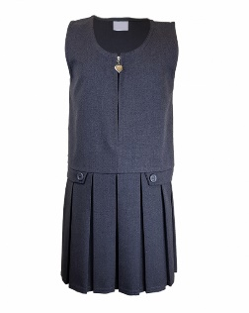
- Nursery and Reception children - Black jogging bottoms
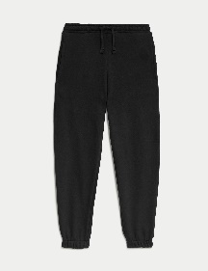
- Summer uniform – red and white checked dress / grey school shorts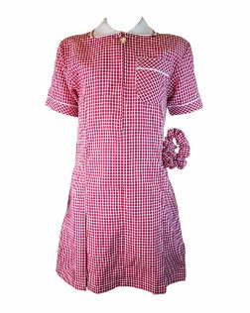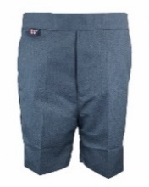
- PE trousers (winter) Reception to Year Six - Black jogging bottoms
- PE shorts (summer) Reception to Year Six – Black shorts
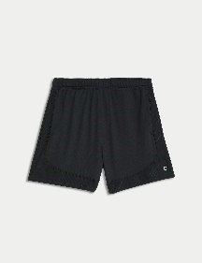

- Grey socks / white or grey tights
- Plain black trainers or shoes suitable for learning and playing – No other colours present on the trainers are permitted.
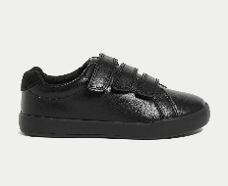

All items of clothing should be named.

Make up and nail varnish
Make up and nail varnish are not permitted to be worn in school at any time. Children who arrive in school wearing make up and/or nail varnish will be asked to remove it.

Jewellery
Children are not allowed to wear jewellery such as rings, earrings or bracelets to school. If a child has pierced ears, a plain round stud may be worn but for health and safety reasons this will need to be removed by the pupil for PE and games.

Hair
For safety reasons, long hair should be tied back at all times. The school does not permit extreme styles of haircuts, eg. Mohican, shaved lines, or dyed hair

